

Topic: 30th National Assembly:

**The Gift of Living Water**

*Communion with God and One Another: CCA 50 years and Beyond*

Dear Sisters, January 15, 2020

First of all, we wish you God’s blessings in this New Year, and assure you of our prayers

for each of you and your communities.

So much has been happening this past year, both throughout the nations, peoples, and

creatures of our world, as well as in our Church, contemplative religious communities of

women, and in our own Carmelite communities worldwide.  We are truly grateful for the

ongoing communication with sisters from our US Associations and international

Federations as we journey together into an unknown and grace-filled future. You may at

times have felt that we were flooding you with information, yet we believe that at this

time in history it is even more important to share communications which touch each of

our lives.  Digital communication can be both a blessing and frustrating!

We are excited to share the fruits of our 2020 General Assembly planning team *(see all*

*the attachments)* and hope that as many members of your communities as possible may

be able to participate with us at Bon Secours this coming June. By now you should have

received a hard copy of our beautiful brochure. Extra ones will be available at our

Assembly for member and guests to share with their communities. Many thanks to

Sr.Cecelia for her creative design!

**Costs (Bon Secours)**

Although, through Sr. Marjorie’s diligent work, our Tax Exempt Status was reinstated

retroactively in 2018, we have not yet received enough grant funding to cover costs for

our 2020 Assembly. So it is still necessary to ask our communities to cover the full

expense of room and board. We will not know until late April if we will receive a large

grant. If we do, we will refund a portion of room and board to each community. Even

though $685 per person for the Assembly days (including $25 registration fee) seems

very high, other venues cannot match both being near to a major airport and the

amenities that Bon Secours offers (room/board, snacks, break-out rooms, chapel

availability, free parking, Wi-Fi, all our technology needs, and a staff at our service as

needed).

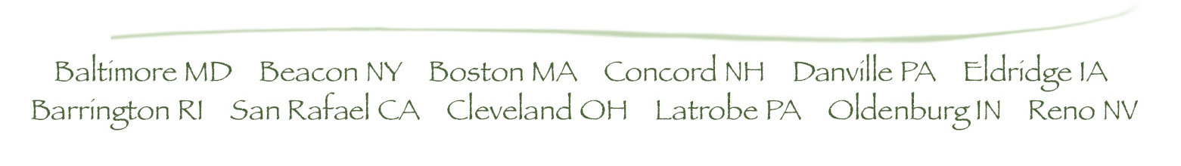

With the increase of costs for this meeting, we want to make every effort to ensure that

no one is prevented from attending because of financial need. Marjorie is encouraging

any of our communities who may need financial assistance to be in touch with her. We

will make it work for you! Please note: because we are obliged to give Bon Secours full

payment in advance for all registered, after APRIL 15, payment will be non-refundable.

**REGISTRATION AND PAYMENT FORMS**

Please note, the due date for returning registration forms to Sr. Roz, and the payment

form and check to Sr. Marjorie is MARCH 15. If we are below or above our estimated

number of attendees, we may still be able to negotiate with Bon Secours 90 days in

advance.

**GROUND TRANSPORTATION INFORMATION**

This year we are asking each community or sister who is flying: please reserve and pre-

pay for a ground transportation service from BWI (Baltimore airport) to and from Bon

Secours. See attachment for possible services. Baltimore Carmel is generously hosting

some of our international guests and will be providing transportation only for their guests.

**PRE-MEETING**

The pre-meeting will take place from June 5 to June 7. We have invited representatives

from our US Associations and International Associations to share their recent Gent

experiences and also to suggest questions and topics that they and their communities

would like to address. Stephanie Hauge will facilitate the pre-meeting as she did the last

time. We plan to share the fruits of this meeting with the whole Assembly.

**PRIORESS’ MEETING**

The CCA Prioresses will arrive on Saturday, June 6 and will be meeting all day Sunday,

June 7. We thank Sr. Mary Wild for coordinating this meeting.

**ELECTION INFORMATION**

For your information, our 2020 election will be for a two-year term because our current

Statutes are valid until the time when we have voted on revised Statutes and they have

been accepted by Rome.  You will be receiving more information early to mid February.

As we begin 2020, let us pray for each other, for all our sisters and brothers throughout

our world, and for all of creation.

**Attachments:**

1. Brochure

2. Registration Form

3. Payment Form

4. Ground transportation information to/from Airport

5. Proposal Forms for CCA members

In union of love and prayer,

