

Dear Sisters, February 25, 2019

Warm greetings to each of you from your Leadership Team!

In line with CCA's goal 4, your LT has been pondering practical ways that CCA might be of greater support to our communities. Goal 4 is stated thus:

*We have continued to provide active, mutual support to the identified needs of our*

*communities, in particular, sisterly visits of each member community by the Leadership*

*Team or delegates in the next term.*

We are writing to you *to assess your interest* in a shared services collaborative amongst our membership, the plans for which your LT can pursue by way of a potential grant funding opportunity that has arisen. The potential grant provider is the GHR Foundation. At this point Stephanie Hauge and Sr. Bernadette Therese have had one conversation with GHR. GHR recently provided a large grant to a group of active religious congregations to establish the Wisconsin Religious Collaborative. We provide you below with information about how this opportunity was initiated and what the Wisconsin Religious Collaborative is about.

Our purpose is to ask you to respond to some questions in order for your LT to determine if you are open to planning for a similar project and if it might service the needs of our CCA communities.

**Background:**

Through an introduction by Sr. Joan Marie Steadman, CSC (former Executive Director of LCWR) to the GHR Foundation, Sister Bernadette Therese and Stephanie Hauge had an opportunity to have a conversation via ZOOM with Kathleen Mahoney, Director of the Sisters Initiative at the GHR Foundation. Sr. Joan had made us aware that GHR Foundation had provided funding for Region 9 of LCWR to form the Wisconsin Religious Collaborative.

Sister Bernadette Therese and Stephanie Hauge were then referred to Sr. Pat Cormack, SCSC, Provincial of the Holy Cross Sisters, Merrill WI, President of the Wisconsin Religious Collaborative, for a conversation regarding the collaborative. Over a period of

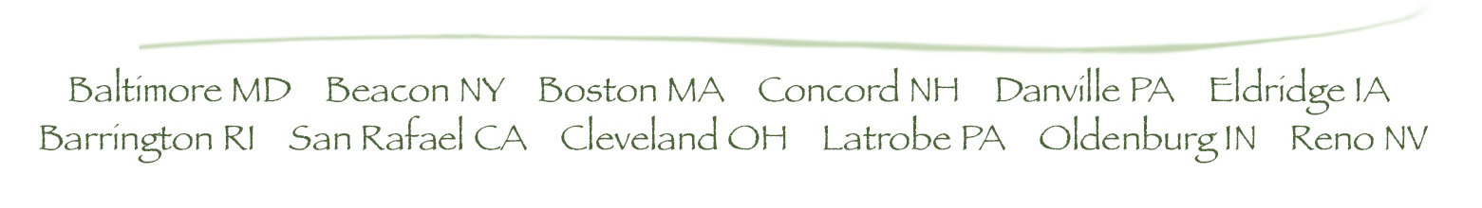three years, different religious communities that form Region 9 of LCWR collaborated to incorporate a shared service organization that is also a 501c3 (a non profit organization). After conducting significant research and consulting with canonical, civic and financial experts, they drafted and approved by-laws, incorporated, established founding members, agreed upon a funding model, and recently hired an Executive Director. The mission of the collaborative *is to provide a sustainable membership organization that promotes good stewardship by sharing resources and professional expertise in finance, management, pastoral care, governance, and other areas in order to sustain mission and meet the needs of individual religious institutes in Wisconsin and their members.*

As a result of these conversations and in light of CCA's goal 4, we propose gathering some initial information to determine if CCA could begin some collaborative planning. For now, it is just an assessment of interest in shared services to evaluate the possibility of having some kind of 'central office' perform functions that can be done on behalf of each community. There are no mergers or anything of the kind; rather, it involves centralizing  the handling of some administration, healthcare and other issues that are being performed by individual communities which might lighten their burden. This information would then potentially be used to develop a proposal to ask for grant support from GHR to explore how best to proceed with planning and how to perform the identified services.

*Answering the attached questions would be a first step.* Thank you for considering this. Please provide your responses **by March 31, 2019**.

If you are interested in learning more about what is happening in some communities of sisters with diminishing membership, here is a link:

<http://www.globalsistersreport.org/news/trends/collaborative-governance-model-helps-congregations-carry-limited-resources-51886>

Your Sisters,

