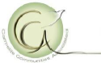Communiqué from CCA Executive Director
May 11, 2026

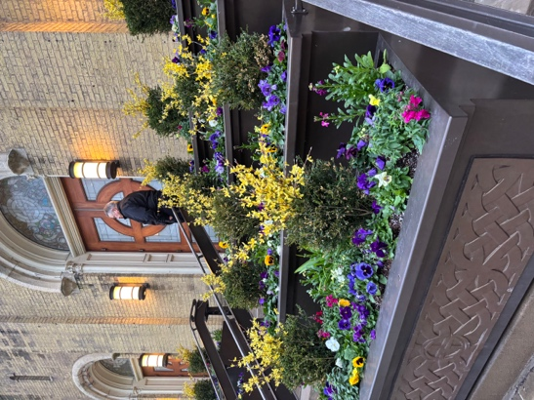
With earnest hope that the winter has departed us for good and that spring will continue to make its way into our hearts and homes, I wish you Easter blessings of hope and new life. I was in Chicago for the Triduum and outside of church after Holy Saturday Vigil, a jokester was wishing everyone a merry Christmas, as the temperatures were about equivalent!

In the past few months, since the winter Communiqué, I have been engaged primarily with the Governance Board, various delegations, and my two mentors on the Board, Marjorie and Colette. The Governance Board meets monthly, with abundant preparation in advance and a list of follow up tasks. But progress is aplenty!
Spring flowers at Old St. Patrick’s Church, Chicago
Some highlights will follow below

Ellen Dauwer, SC

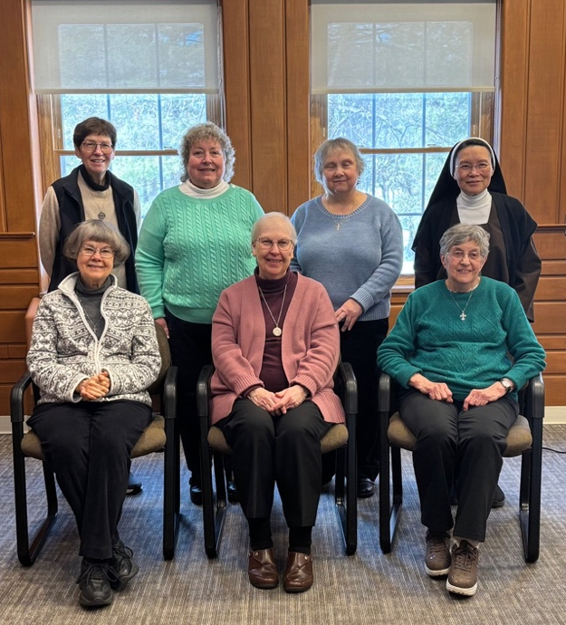
GOVERNANCE BOARD
The Board met in person for two full days in February, as reported in the Winter Communiqué. Since that time the Board has met monthly, though hopes to take a pause in mid-summer. At our most recent meeting, the group accepted the proposal that Sister Mary Fleig delegate her seat on the Board to Sister Judy Long for a period of six months. This enables Mary to focus on beginning her ministry as prioress and also fosters the developing relationships among the members of the Governance Board. Mary will join the Board at the in-person meeting in October. In the meantime, she will be apprised of all its actions through the minutes.
Governance Board meeting in Cleveland
(Mary Wild joined via Zoom)
One of the key areas of focus of the Governance Board is greater outreach and inclusion of unincardinated Sisters. Judy Long will be doing some initial follow up, while the Board continues to discern next steps. Additionally, all (particularly unincardinated Sisters) are invited to participate in the livestreamed liturgies and other offerings of the Baltimore and Reno Carmels.

- To request being put on their mailing list for e-newsletter updates, and Zoom links for their liturgies and programs email: Maryfleig@baltimorecarmel.org in Baltimore and/or Claire@carmelofreno.net in Reno.

As the Governance board continues to evolve in its role and functions, we have dedicated some time to defining more carefully each of the leadership roles. We are also fleshing out the budget process in order to steward resources now and into the future.

DELEGATIONS
Each of the delegations is up and running. Many are composed of Sisters who have been engaged in the work for a while; others are newly constituted. I head up the Ongoing Formation delegation but have also met with and support the other groups in their work. Here are some updates from them.

Website
There are several updates to the CCA website. One is the posting of the Factual Report of the 2025 Assembly. Another is the inclusion of materials on the updating of the Constitutions. There are now 2 tabs for this purpose; one labeled Updating Constitutions, the other Constitutions – Formative Videos. The formative materials are produced by the Generalate and include a video, outline and text of the video explaining different aspects of our charism in the Constitutions. They can be accessed using this link: https://ccacarmels.org/members/ (Password for Members Only section is CCA2025. Please jot it down for future reference.)

We encourage all to send photos, obituaries and memorials of deceased sisters since 1970 to Sisters Shirley Marie ssmaocd@gmail.com and Jeanne Marie sjmocd@gmail.com for the website.

Fundraising
The fundraising delegation has turned its attention to seeking grant funds and donations for the 2027 Assembly (more on the Assembly below). Stephanie submitted a Letter of Invitation to the Koch Foundation and Michaelene secured a generous donation to help to fund the Assembly. We are researching and following up on a few other grant possibilities for the future.
Newsletter
The most recent issue of the CCA newsletter came out in late February. It contained updates from most of the monasteries. Always an interesting read thanks to the hard work of Donna!

Ongoing Formation
The first offering of this newly formed delegation was the Lenten program given by Sister Barbara Reid, OP. We received much positive feedback from it; the recording and handouts are posted on the CCA website (members only section). Sister Mary Frohlich, RSCJ will offer a program on the Sacred Heart in June; a save the date flyer was recently emailed to all.

We continue to collaborate with others who invite CCA members to participate in ongoing formation programs: Queen of Carmel Association (webinars given by Fr. Marc Foley, OCD on St. Teresa) and the Carmelite Nuns of Great Britain (Living the Vow of Poverty in Today’s Context).

2027 ASSEMBLY
The next CCA Assembly will be held at the Bon Secours Retreat Center in Marriottsville, MD from May 23 to 27, 2027. It will be offered in a hybrid format, allowing for both in-person and on-line participation. We are in the initial planning stages of this important gathering as well as a discernment process to precede it.

UPCOMING CCA DATES
- May 14, 2026 - Governance Board meeting
- June 9, 2026 - Ongoing Formation: Sr. Mary Frolich, RSCJ on the Sacred Heart
- June 24, 2026 - Ongoing Formation: Fr. Marc Foley, OCD – Talk #5 on St. Teresa (QofC)
- June 22, 2026 - Governance Board meeting
- October 26-29, 2026 - Governance Board: Annual in person meeting – Cleveland

GOVERNANCE
Sisters fulfilling canonical roles:
President: Marjorie Robinson
First Councilor: Colette Ackerman
Treasurer (Councilor): Barb Losh
Secretary (Councilor): Claire Sokol
Formator: Claire Sokol

Responsibilities of Governance Board Members:
Marjorie: Communications with Generalate and Rome (Dicastery for Institutes
of Consecrated Life and Societies of Apostolic Life) and work closely with Colette and Ellen. Visitations. Prioress of affiliated Carmels.

Colette: Consult and work closely with Marjorie and Ellen.

Barb: Oversight of CCA’s treasurer, Holly Borzacchiello.

Claire: Prepare Agenda and Minutes of Governance Board meetings; emails CCA communications

Claire: CCA’s Canonical representative for ongoing formation and CCA’s liaison for International Commission on the updating of the Constitutions: sharing updates, engaging members with feedback processes and sending feedback to Rome.

Judy Long: Oversight of health-care needs of affiliated sisters in CCA.

Ellen: Executive Director (non-voting member)

Delegations:
Ongoing Formation
Sister Ellen Dauwer, SC
Sister Jeanne Marie Graham
Sister Jo Robson
Sister Colette Ackerman (advisor)
Sister Mary Fleig/assistant (Zoom assistance)
Sister Claire Sokol, available for consulting

Newsletter
Sister Donna Schultz

Fundraising
Sister Michaelene Devine
Stephanie Hauge
Sister Judy Murray
Website
Sister Shirley Marie Ahern
Sister Jeanne Marie Graham
New Address for Sr. Sue Lumb: Alliance Health at Marie Esther
720 Boston Post Rd. E
Marlborough, MA 01752

