December, 2025

Very dear Sisters:
May the peace and grace of Jesus fill your hearts during this Christmas season!
With this email, we begin sending you the formation material we announced.
This material consists of a series of talks offered by some of our Carmelite Brothers on topics related to the draft table of contents currently under review. This first installment addresses the process of revising our Constitutions. We have also selected some points that we reflected on in the Commission in order to carry out our work: the Teresian charism (chapters 1 and 3); the Virgin Mary (chapter 1); and the apostolic dimension of our life (chapter 4). Videos on these topics will be sent periodically.
Here is the YouTube link for the first video https://youtu.be/GM0w4_V6Sho?si=7Vhw6V8kjEKZMYTi
With much gratitude, let us continue together to follow the Star that will lead us to the Child of Bethlehem.
Your Sisters and Brothers of the Commission.

--
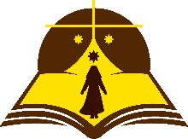
Comisión Internacional para la revisión de las Constituciones 1991
International Commission for the revision of the Constitutions 1991

